Ze Vigenere Tool

As per the given instruction, there were some challanges to build this application but worth coding.

Following are the functionalities of the application.

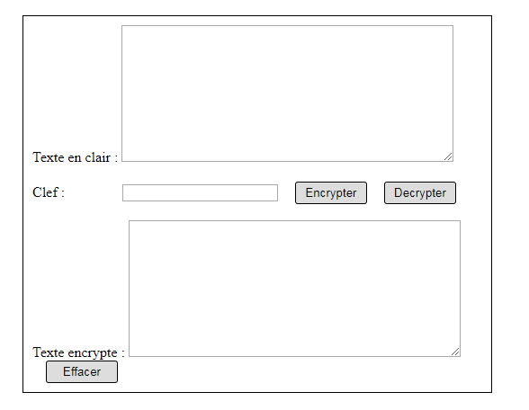

Note: To decrypte the information, we will enter the encrypted text in the respective textarea and then key to the clef box. As soon as we press Decrypter button, the decrypted message will be shown in the texte en clair box.

3. In the third step, to get the Encrypted text in the Texte encrypte box, we need to press the Encrypter button.

1. This is the place where plain text will be entered first.

2. In the second step, the key will be entered into the clef textbox.

Process of Encryption

1.

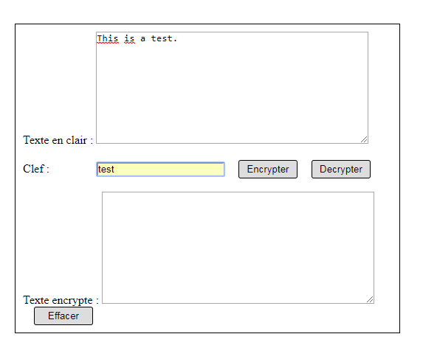

2.

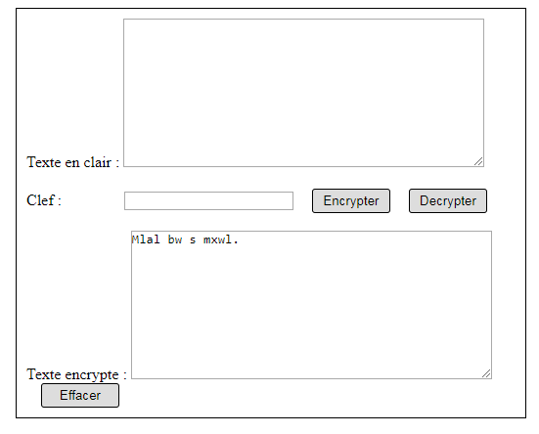

Decryption

1.

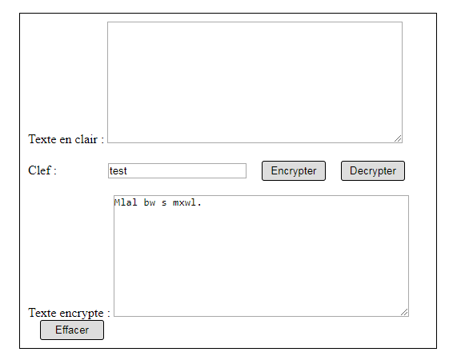

2.

